**Department of Computer Science and Engineering Data Science**

**Subject: -Computation Linguistics Sem: VI**

**Date of Submission:-30th April 2023**

**Assignment No 2**

**Chapter 3 Syntax Analysis**

1. Explain Constituency Parsing​ with help of example.
2. Explain Types of ambiguity ​in Constituency parsing with the help of example.
3. Explain CKY Parsing algorithm for parsing a given string with the help of example.
4. How to Convert CFG to CNF ​?
5. Consider the following CFG in CNF form

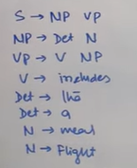

Parse the following sentence **The flight includes a meal** using CKY algorithm.

1. Explain Dependency parsing with the help of example.
2. Explain terminologies as well used for Dependency parsing​.
3. how to create a dependency parse tree-Shift Reduce Parsing (Arc standard) algorithm?
4. For the CFGs given:

S → NP VP

VP → V NP

NP → Det N

Draw the shift-reduce parser in processing the sentence

**the policeman saw the thief**

Use the following lexical entries to create the chart parser.

Det → The | a

N →Policeman | thief

V→saw

1. What is Need of Parsing?
2. Explain Probabilities parsing with the help of suitable example.

​

**Chapter 4 Semantics Analysis**

What is semantic analysis? Why is it difficult? Explain various

approaches to semantic analysis.

2. Explain with suitable examples following relationships between word meanings Homonymy, Polysemy, Synonymy, Antonymy, Hpernomy, Hyponomy, Meronymy.

3. What is semantic analysis? Discuss different semantic relationships between the words.

4. What is WordNet? How is sense defined in WordNet? Explain with example.

6. What do you mean by word sense disambiguation? Discuss knowledge based approach for WSD.

7. What do you mean by word sense disambiguation? Discuss machine learning based (Naïve Bayes) approach for WSD.

8. Explain how a supervised learning algorithm can be applied for word sense disambiguation

9. Explain Bag of words with the help of suitable example.

10.Explain vector semantics analysis.

11.Explain what is Distributional Hypothesis​.

12. Explain word space and vector space in distributional semantics.

13. What is One-hot representation​? explain with example.

15 Explain steps in building distributional semantics model.

16. Consider the following sentences and represent it into term document matrix format.

D1: Text mining is to find useful information from text.

D2: Useful information is mined from the text.

D3: Dark came.

17. Consider the above example calculate the TFIDF score for the same.

18. Consider the matrix given below and calculate the point wise mutual information for the word (Digital, Computer)

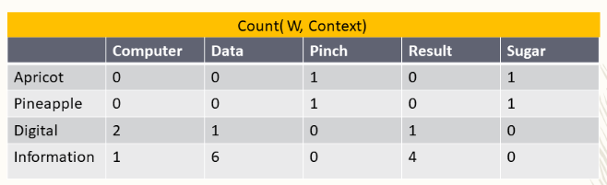

20. Discuss the Problem with raw dot-product​ for finding the similarity between the vectors.

21.Consider the following matrix and find the cosine similarity between (cherry, data) and (digital, data)

|  |  |  |  |
| --- | --- | --- | --- |
| **​** | **pie​** | **data​** | **computer​** |
| cherry​ | 442​ | 8​ | 2​ |
| digital​ | 5​ | 1683​ | 1670​ |
| information​ | 5​ | 3982​ | 3325​ |

22.What are the disadvantages of TFIDF method.

23. Explain Word2Vec​ method in detail.

24. Explain the working of continuous bag of words in details with the help of suitable example

25.Expalin the working of skip gram model in detail with the help of suitable example.

26. Consider the following dataset and find the class label for test data using Naïve Bayes algorithm.

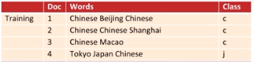



27. Explain how to perform WSD Using Random Walk Algorithm​ using suitable example.

**Chapter 5 Discourse analysis.**

1. Explain coreference and anaphoric reference with the help of example?
2. Explain the working of Hobbs Algorithm to build the reference resolution system
3. Write a short note on the Terminology Used in Reference Resolution.
4. Explain Discourse Model​ with help of suitable example.
5. Differentiate between anaphora and coreference.
6. What are the types of Referring Expressions and types of referents​ ​? Explain with suitable example.
7. Explain the constraints and preferences in reference Resolution.